Name______________________________________Class:_________________Date:____/____/____

Inductance

Lab Activity #1 – Determine Transformer Ratios

Equipment and materials

- Filament transformer (step down approximately 110v to 6v)

- Autotransformer or signal generator

- 30-ohm, 5W resistor

- Multimeter

- Electrical wire to build circuit
Procedure

1. Construct the following circuit (Figure 1)
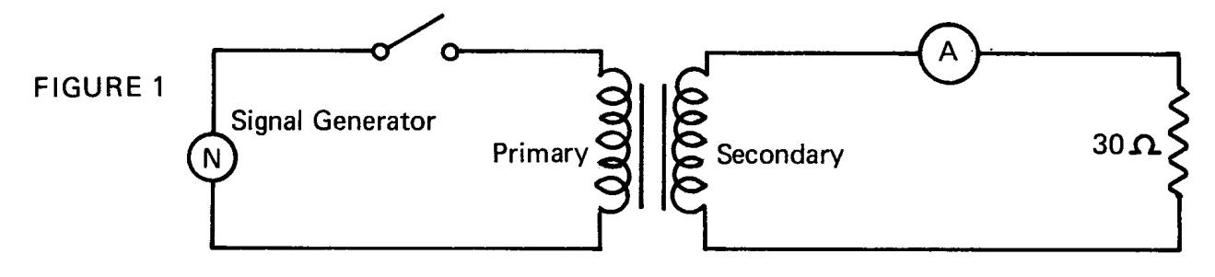

- Adjust the signal input to 100 volts

- Close the switch and record the secondary current, (I_{S})

- Measure and record the primary voltage, (V_{P}) _______ _____

- Measure and record the secondary voltage, (V_{S}) ______ ____

- Measure and record the load resistor (approximately 30 ohms) _______

- Compare the measured secondary current (I_{S}), with that obtained using Ohm’s law (V_{S}/R_{L}), and explain the difference ____________________________________________________________________________________

- Measure and record (I_{P}) _____________ _____

- Calculate the turns ratio of the transformer ______________________________________
____________________________________________________________________________________

- Remove the load resistor and leave the secondary open

- Measure and record the primary current (I_{P}), with an open secondary
_________________ _____

- Compare your voltage ratio with that indicated by this transformer manufacturer

- Turn off circuit, disconnect components, and place materials in the proper storage area

