DC Circuits Quiz
- Where does a voltmeter go in a circuit? (How does a voltmeter connect to measure voltage?)
  - In the circuit just after the power supply
  - Across the device to be measured
  - In the circuit just before the power supply
  - In series with the load

- Where does an ammeter go in a circuit? (How does an ammeter connect to measure current?)
  - Across the power supply
  - Across the load
  - Same as for voltage
  - In series with the load

- Which of the following is a protection element?
  - Fuse
  - Switch
  - Wire
  - Ground

- Which of the following is a control element?
  - Fuse
  - Switch
  - Wire
  - Ground

- How are battery cells connected to make a battery?
  - Positive to positive
  - Negative to negative
  - In series with each other
  - In parallel with each other

- Which of the following is the schematic symbol of a battery?
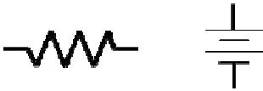
a. b. 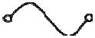 c. d.

(alternate) Draw the schematic symbol of a battery and label the polarity.
- What is usually done with the negative side of a battery?
  - Connect to the positive side of the battery
  - Connect to ground
  - Connect to a resistor
  - Connect to a fuse

- Which of the following is not a physical device?
- Fuse
- Switch
- Wire
- Ground

- Why is ground voltage defined to be zero volts?
- To be a common reference for all voltage measurements
- Because there is never any voltage on ground
- To allow you to measure voltage and current the same way
- Because ground is isolated from the rest of the circuit

- Why is ground usually connected to the most negative point in a circuit?
- To be a common reference for all voltage measurements
- Because ground is isolated from the rest of the circuit
- To make every voltage measured to ground a positive voltage
- To make ground a protection element

- Why is ground also called common?
- Because it connects to both sides of the power supply
- Because it is shared with many components
- Because there is nothing special about ground
- Because it only connects to one device

- Which of the following is the symbol for ground?

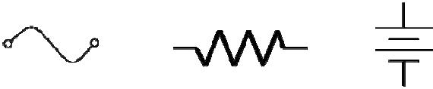
a. 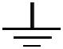 b. c. d.

(alternate) Draw the schematic symbol for a ground.
- What does a fuse protect?
  - People
  - Ground
  - Lawyers
  - The circuit

- What do you do with a fuse once it blows?
  - Replace it with a bigger fuse
  - Replace it with the same size fuse
  - Replace it with a smaller fuse
  - Replace it with a wire

- Which of the following is the symbol for a fuse?

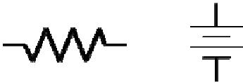
a. 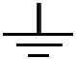 b. 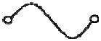 c. d.
(alternate) Draw the schematic symbol for a fuse.

- Which of the following is the most often used component in a circuit?
  - Power supply
  - Ground
  - Resistor
  - Fuse

- How is resistance value of a resistor usually indicated?
  - A color band
  - The size of the resistor
  - The number of leads
  - A small number of the side

- What determines the power rating of a resistor?
  - A color band
  - The size of the resistor
  - The number of leads
  - A small number of the side

- What does a resistor do?
  - Turns on or off a circuit
  - Protects a circuit from too much current
  - Provides a common return path for current
  - Used to limit or restrict current

- Why doesn’t a voltmeter change circuit voltage values?
  - Because it is never connected directly to the circuit
  - Because it has almost infinite internal resistance
  - Because it has almost zero internal resistance
  - Because it uses its own internal voltage

- Why doesn’t an ammeter change circuit current values?
  - Because it is never connected directly to the circuit
  - Because it has almost infinite internal resistance
  - Because it has almost zero internal resistance
  - Because it uses its own internal current

- What two things must an electric circuit have?
  - A power supply and ground
  - A power supply and a load resistance
  - A switch and a fuse
  - A fuse and a load resistor

- What direction does current flow?
  - Always out of the power supply
  - Always into the power supply
  - Positive to negative
  - Negative to positive

- What formula shows the relationship between voltage, current, and resistance?
  - Ohm’s Law
  - Watts Law
  - Pascals Law
  - Newtons Law
(alternate) Draw the Ohm’s Law circle
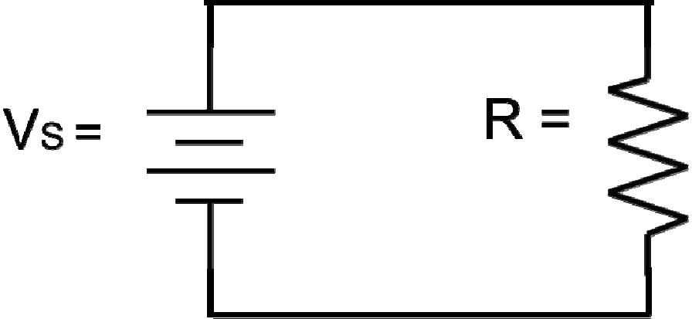

- VS = 25 V, R = 455 Ω. What is I?

- V_{S} = 9 V, I = 13.6 mA. What is R?

- I = 48 mA, R = 1125 Ω. What is V_{S} ?
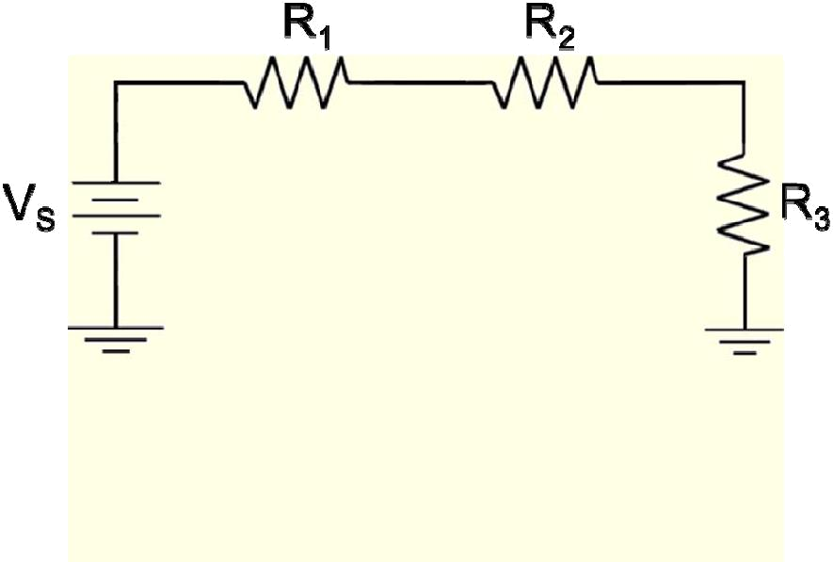

- What is R_{T}?

- What is IT?

- What is V1?
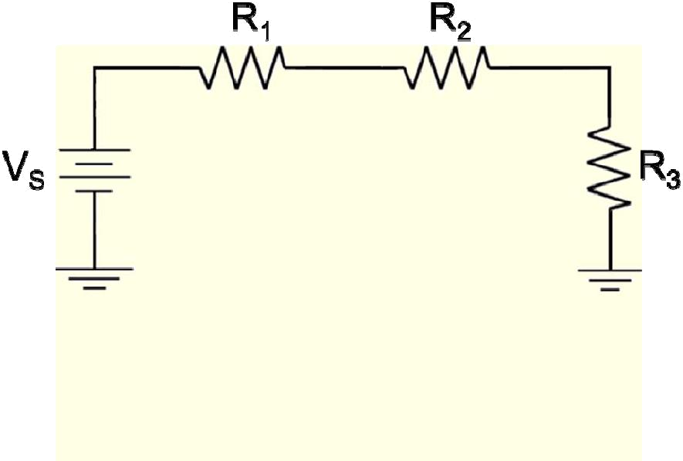

V_{S} = 27 V, V₁ = 7 V, V₂ = 6 V, R₃ = 600 Ω
- What is R₁?

- V_{S} = 18 V, V₁ = 6 V, R₃ = 600 Ω, I_{T} = 6 mA

What is R2?

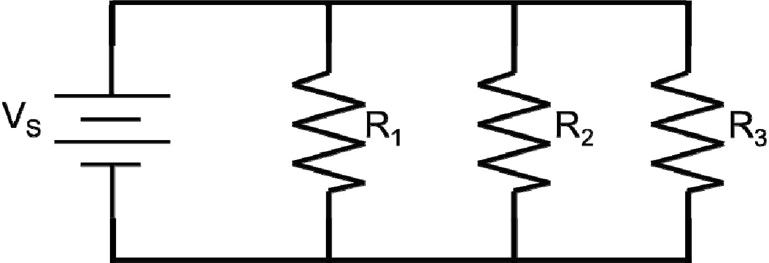

33.
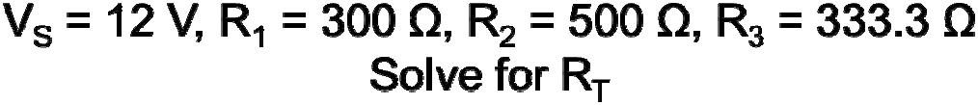

34. Solve the previous problem for I_{T}.

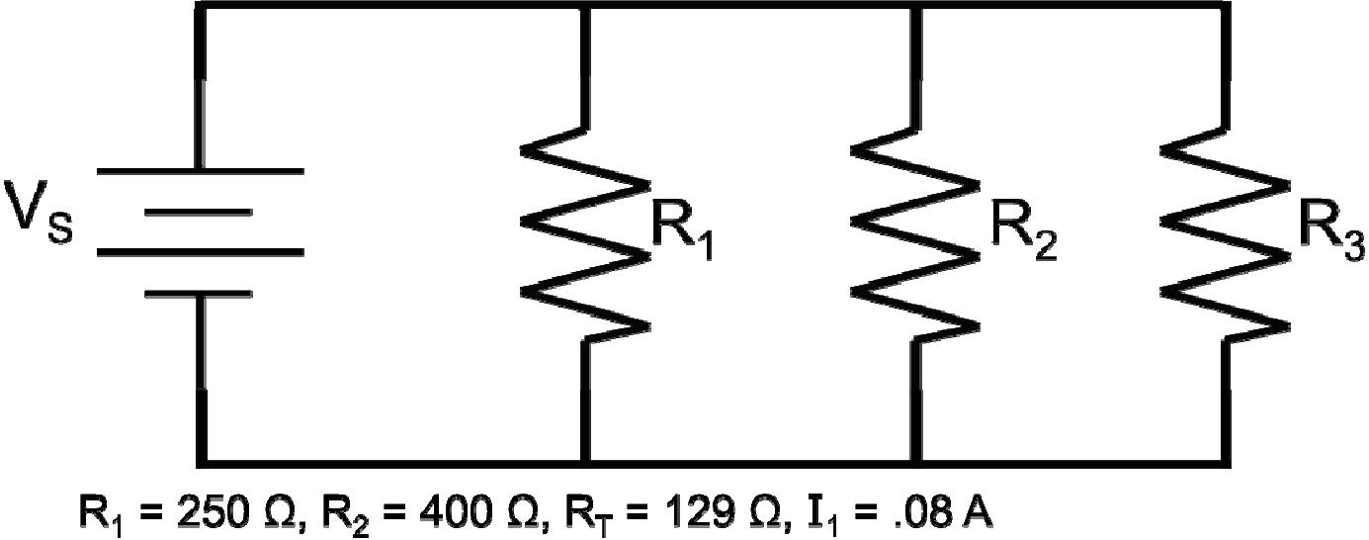

35. Solve for I₃.

