DC Circuits Quiz Key

- Where does a voltmeter go in a circuit? (How does a voltmeter connect to measure voltage?)
  - In the circuit just after the power supply
  - Across the device to be measured
  - In the circuit just before the power supply
  - In series with the load

- Where does an ammeter go in a circuit? (How does an ammeter connect to measure current?)
  - Across the power supply
  - Across the load
  - Same as for voltage
  - In series with the load

- Which of the following is a protection element?
  - Fuse
  - Switch
  - Wire
  - Ground

- Which of the following is a control element?
  - Fuse
  - Switch
  - Wire
  - Ground

- How are battery cells connected to make a battery?
  - Positive to positive
  - Negative to negative
  - In series with each other
  - In parallel with each other

- Which of the following is the schematic symbol of a battery? (Answer is d.)
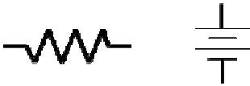
a. b.  c. d.

- What is usually done with the negative side of a battery?
  - Connect to the positive side of the battery
  - Connect to ground
  - Connect to a resistor
  - Connect to a fuse

- Which of the following is not a physical device?
- Fuse
- Switch
- Wire
- Ground

- Why is ground voltage defined to be zero volts?
  - To be a common reference for all voltage measurements
  - Because there is never any voltage on ground
  - To allow you to measure voltage and current the same way
  - Because ground is isolated from the rest of the circuit

- Why is ground usually connected to the most negative point in a circuit?
  - To be a common reference for all voltage measurements
  - Because ground is isolated from the rest of the circuit
  - To make every voltage measured to ground a positive voltage
  - To make ground a protection element

- Why is ground also called common?
  - Because it connects to both sides of the power supply
  - Because it is shared with many components
  - Because there is nothing special about ground
  - Because it only connects to one device

- Which of the following is the symbol for ground? (Answer is a.)

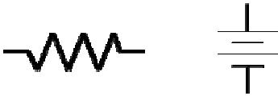
a. 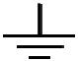 b. 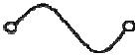 c. d.

(alternate) Draw the schematic symbol for a ground.

- What does a fuse protect?
  - People
  - Ground
  - Lawyers
  - The circuit

- What do you do with a fuse once it blows?
  - Replace it with a bigger fuse
  - Replace it with the same size fuse
  - Replace it with a smaller fuse
  - Replace it with a wire

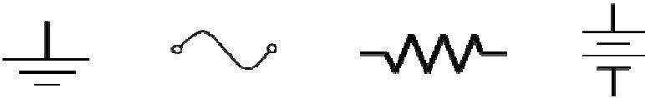
- Which of the following is the symbol for a fuse? (Answer is b.)

a. b. c. d.
(alternate) Draw the schematic symbol for a fuse.

16. Which of the following is the most often used component in a circuit?
- Power supply
- Ground
- Resistor
- Fuse

- How is resistance value of a resistor usually indicated?
  - A color band
  - The size of the resistor
  - The number of leads
  - A small number of the side
  - A small number of the side+/8888888886666666666666666666666666666666666666666666666666666666666666666666666666666666666666666666666666A small number of the side

- What determines the power rating of a resistor?
  - A color band
  - The size of the resistor
  - The number of leads
  - A small number of the side

- What does a resistor do?
  - Turns on or off a circuit
  - Protects a circuit from too much current
  - Provides a common return path for current
  - Used to limit or restrict current

- Why doesn’t a voltmeter change circuit voltage values?
  - Because it is never connected directly to the circuit
  - Because it has almost infinite internal resistance
  - Because it has almost zero internal resistance
  - Because it uses its own internal voltage

- Why doesn’t an ammeter change circuit current values?
  - Because it is never connected directly to the circuit
  - Because it has almost infinite internal resistance
  - Because it has almost zero internal resistance
  - Because it uses its own internal current

- What two things must an electric circuit have?
- A power supply and ground
- A power supply and a load resistance
- A switch and a fuse
- A fuse and a load resistor

- What direction does current flow?
  - Always out of the power supply
  - Always into the power supply
  - Positive to negative
  - Negative to positive

- What formula shows the relationship between voltage, current, and resistance?
  - Ohm’s Law

  - Watts Law
  - Pascals Law
  - Newtons Law

(alternate) Draw the Ohm’s Law circle
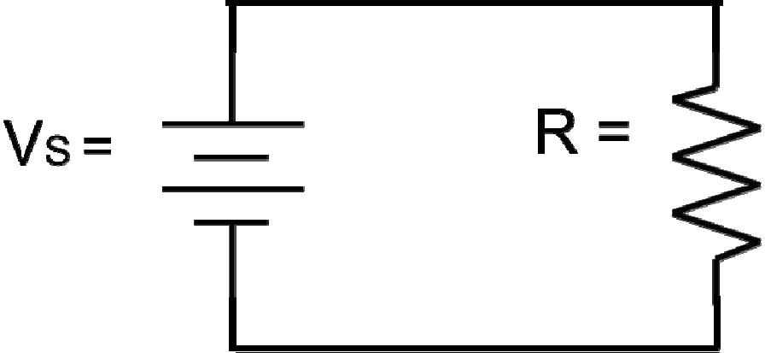

- V_{S} = 25 V, R = 455 Ω. What is I?

.055 A or 55 mA

- V_{S} = 9 V, I = 13.6 mA. What is R?

660 Ω

- I = 48 mA, R = 1125 Ω. What is V_{S} ?

54 V

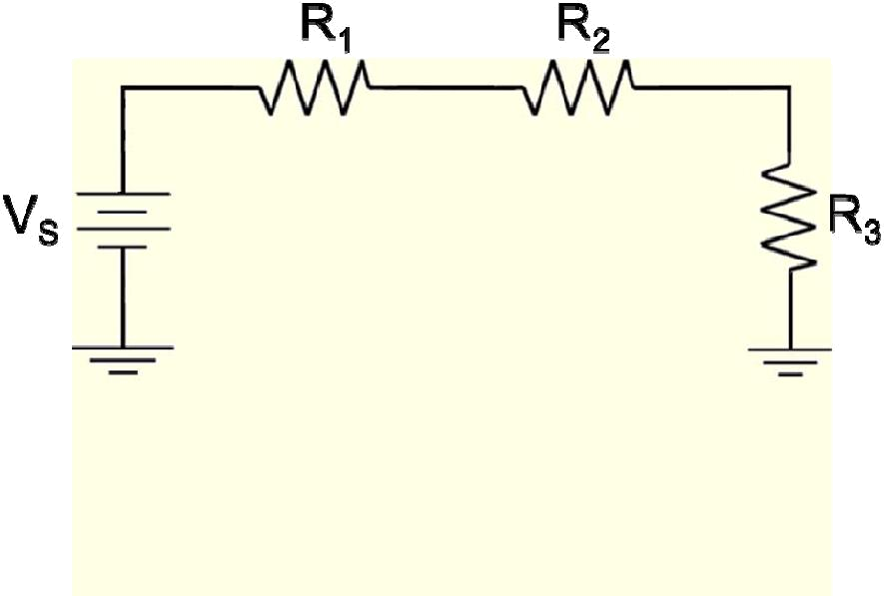

V_{S} = 16 V, R₁ = 250 Ω, R₂ = 150 Ω, R₃ = 400 Ω

- What is R_{T}?

- Ω

- What is I_{T}?

20 mA

- What is V₁?

5 V

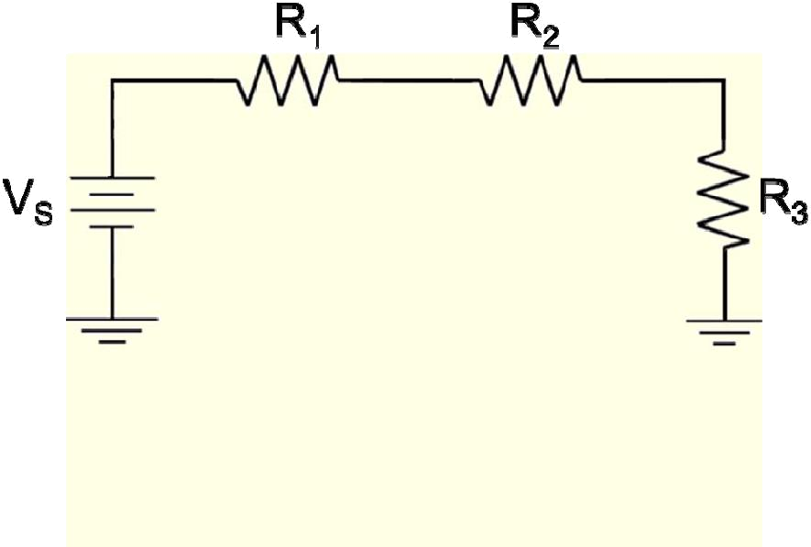

V_{S} = 27 V, V₁ = 7 V, V₂ = 6 V, R₃ = 600 Ω

- What is R₁?

  - Ω

- V_{S} = 18 V, V₁ = 6 V, R₃ = 600 Ω, I_{T} = 6 mA

What is R2?
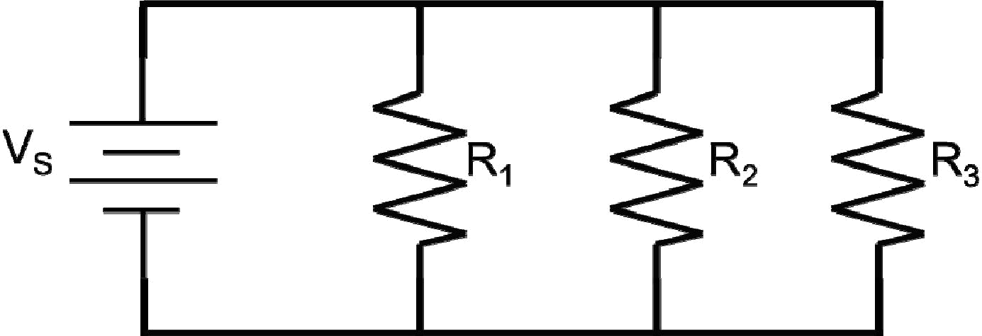
1400 Ω or 1.4 kΩ

33.
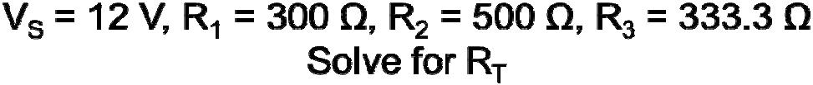

120 Ω

- Solve the previous problem for I_{T}.

1 A or 100 mA
35. Solve for I₃.

.025 A or 25 mA

Solution 1 - Problem 1 – Slide 21

- What is total resistance?
R_{T} = R₁ + R₂ + R₃ = 250Ω + 150Ω + 500Ω = 900Ω

- What is total current?
I_{T} =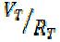= 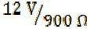= .01333 A = 13.33 mA

- What is V₁?
V1 = I₁ x R1 = 13.33 mA x 250Ω = 3.33 V

- Work the problem with V_{S} = 16 V, R₁ = 400Ω, R₂ = 600Ω, R₃ = 1000Ω
Follow steps 1 – 3 above with these new values.
R_{T} = 2000 Ω
I_{T} = .008 A= 8 mA
V₁ = 3.2 V

Solution 2 - Problem 2 – Slide 22

- Write the formula you need: R₁ = 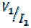 You have V₁, but you don’t have I₁.

Current in a series circuit is the same everywhere, though, so if you can solve for any current you will have I₁.

- The formula for current is voltage divided by resistance, and you don’t seem to have both of those values. However, you have R₃ and can solve for V₃ using the formula

V_{T} = V₁ + V₂ + V₃ or V₃ = V_{T} – V₁ – V₂

V₃ = 20 V – 6 V – 4 V = 10 V

- I₃ =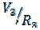= 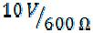 = .01667 A = I_{T} = I₁

- R₁ =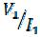 =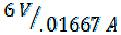= 360 Ω

R₁ = 360 Ω

Solution 3 – Problem 3 – Slide 23

9. Write the formula you need: R₂ = You don’t seem to have either V₂ or
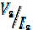
I₂.

In a series circuit, though, current is the same everywhere so I₂ = I₃ = I_{T} = 6 mA

10. Now, you can solve for V₃ using the formula V₃ = I₃ x R₃, where I_{T} = I₃.

V₃ = I₃x R₃= .006 A x 1500 Ω = 9 V

11. V_{T} = V₁ + V₂ + V₃ or V₂ = V_{T} – V₁ – V₃= 18 V – 3 V – 9 V = 6 V

12. R₂ = 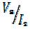 = 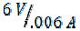 = 1000 Ω

R₂ = 1000 Ω

Solution 4 – Problem 4 – Slide 28
- Write down the equation for I3. I3 =

You don’t seem to have either of the unknowns you need.

- However, you can solve for V1 (which is the same as VS which is the same as V3). V1 = I1 X R1 = .064 A X 250 Ω = 16 V

- You can also solve for R3 because you have R1, R2, and RT.

