|  |  |  |  |  |  |  |  |  |  |  |  |
| --- | --- | --- | --- | --- | --- | --- | --- | --- | --- | --- | --- |
|  |  |  |  | **Understanding Your Child’s Confidential Student Report (CSR)** | | | | | | |  |
|  |  |  | STAAR® |  |
|  |  |  | Academic Readiness |  |  | ***A Guide for Parents*** | |  |  |  |  |
|  |  |  | State of Texas |  |  |  |  |  |  |  |  |
|  |  |  | Assessments of |  |  |  |  |  |  |  |  |
|  |  |  |  |  |  |  |  |  |  |  |  |
|  |  |  |  |  |  |  |  |  |  |  |  |
|  |  |  |  | **STAAR 3–8 Assessments (including STAAR Spanish, STAAR L, and STAAR A)** | | | | | |  |  |
|  |  |  |  | **Grade 3\*** | **Grade 4\*** | **Grade 5\*** | **Grade 6** | **Grade 7** | **Grade 8** |  |  |
|  |  |  |  | Reading | Reading | Reading | Reading | Reading | Reading |  |  |
|  |  |  |  |  | Writing |  |  | Writing |  |  |  |
|  |  |  |  | Mathematics** | Mathematics** | Mathematics** | Mathematics** | Mathematics** | Mathematics** |  |  |
|  |  |  |  |  |  | Science** |  |  | Science** |  |  |
|  |  |  |  |  |  |  |  |  | Social Studies** |  |  |
|  |  |  |  | *Assessments available in Spanish. |  |  |  |  |  |  |  |
|  |  |  |  | **Linguistically accommodated version (STAAR L) available. | |  |  |  |  |  |  |
|  |  |  |  |  |  |  |  |  |  |  |  |
|  |  |  |  |  |  |  |  |  |  |  |  |

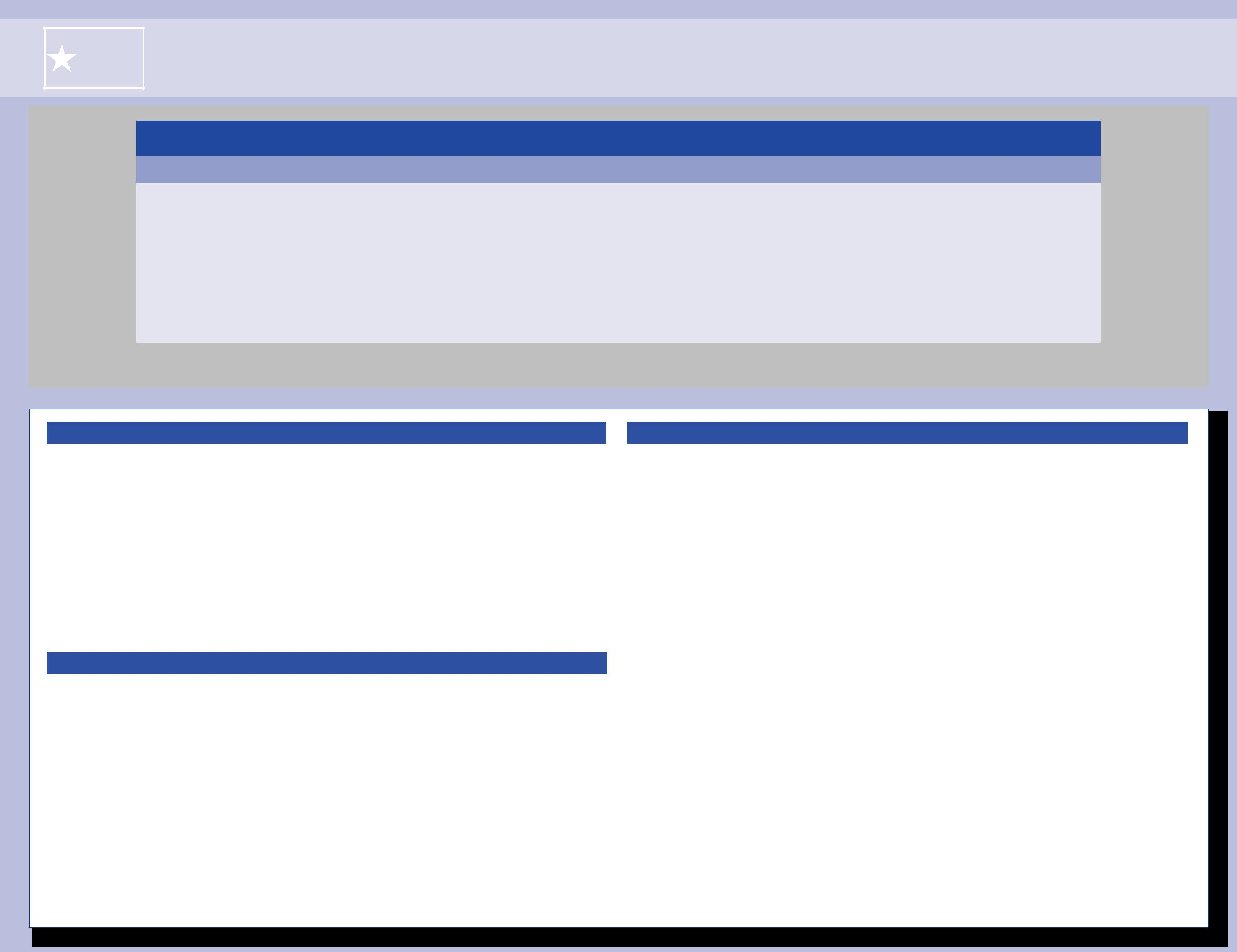

**WHAT IS STAAR?**

The State of Texas Assessments of Academic Readiness (STAAR®) is the testing program for students in Texas public schools. The assessments are based on the Texas Essential Knowledge and Skills (TEKS), the state-mandated curriculum. The curriculum contains the content and skills students need to learn in order to be successful in the current grade and to make academic progress from year to year. Each STAAR assessment measures what students are learning in a specific grade. STAAR L is a version of STAAR for students who are learning English. STAAR L uses linguistic accommodations to help students understand the language of the tests so that they can demonstrate their knowledge and skills. STAAR A is an online accommodated version of STAAR. It provides embedded supports designed to help students with disabilities access the content being assessed.

**WHAT IS THE PURPOSE OF THIS PARENT GUIDE?**

Every child who takes a STAAR test gets a report showing his or her test results. This report is called the Confidential Student Report, or CSR for short. Carefully reviewing your child’s test results can help you identify where your child is doing well and where he or she may need to improve.

This parent guide is based on a sample CSR for grade 7. You will notice that the grade 7 CSR on the next page shows test results for three subject areas: reading, mathematics, and writing. If your child took these subject-area tests at a different grade, his or her results will be reported in the same way as they are at grade 7. If your child took a science or social studies test, his or her test results will be reported in a similar way as the results for reading and mathematics. So no matter what grade your child is in, this grade 7 sample report will help you understand your child’s actual test results.

**WHAT ARE THE PERFORMANCE LEVELS FOR STAAR?**

The STAAR assessments have three categories for performance. The categories are Level III: Advanced Academic Performance, Level II: Satisfactory Academic Performance, and Level I: Unsatisfactory Academic Performance. Your child’s performance level is indicated for each assessment he or she took.

If your child’s report shows a “YES” under Level III: Advanced, he or she performed at a level that was well above passing. Performance in this category indicates that students are well prepared for the next grade and are highly likely to be successful in that grade.

If your child received a “NO” under Level III: Advanced but a “YES” under

Level II: Satisfactory, he or she performed at a level that was at or above passing. Performance in this category indicates that students are sufficiently prepared for the next grade and are likely to be successful in that grade. However, students in this category may need some additional instruction focused on the content and skills that were difficult for them.

If your child’s report shows a “NO” under Level II: Satisfactory, he or she performed at a level that was below passing. Performance in this category indicates that students are not adequately prepared for the next grade and are not likely to succeed in that grade without significant and ongoing instructional support.

|  |  |  |  |  |  |  |  |  |  |  |  |  |  |  |  |  |  |  |  |  |  |  |  |  |  |  |  |  |  |  |  |  |  |  |  |  |  |  |  |  |  |  |  |  |  |  |  |  |  |  |  |  |  |  |  |  |  |  |  |  |  |
| --- | --- | --- | --- | --- | --- | --- | --- | --- | --- | --- | --- | --- | --- | --- | --- | --- | --- | --- | --- | --- | --- | --- | --- | --- | --- | --- | --- | --- | --- | --- | --- | --- | --- | --- | --- | --- | --- | --- | --- | --- | --- | --- | --- | --- | --- | --- | --- | --- | --- | --- | --- | --- | --- | --- | --- | --- | --- | --- | --- | --- | --- |
| **Explanation of Results** | |  | | |  | |  |  |  | | |  | | | | | | | | | |  | |  | | | | | |  |  | | |  |  | |  | |  |  | |  | |  | |  |  |  | |  | |  |  | |  |  | |  |  | |  |
|  |  |  |  |  |  |  |  |  |  |  |  |  |  |  |  | **STATE OF TEXAS ASSESSMENTS OF ACADEMIC READINESS** | | | | | | | | | | | | | | | | | | | | | | | | | | | | | | | | | | | |  |  |  |  |  |  |  |  |
|  |  |  |  |  |  |  |  |  |  |  |  |  |  |  |  |  |  |  |  |  |  |  |  |  |  |
|  |  |  |  |  |  |  |  |  |  |  |  |  |  |  |  |  |  |  |  |  |  |  |  |  |  |  |  |  |  |  | ***Confidential*** | | | | | | | **S*tudent Report*** | | | | | | |  |  |  |  |  |  |  |  |  |  |  |  |  |  |  |  |  |
| **A Reporting Categories** | |  |  |  |  |  |  |  |  |  |  |  |  |  |  |  |  |  |  |  |  |  |  |  |  |  |  |  |  |  |  |  |  |  |  |  |  |  |  |  |  |  |  |  |
|  |  |  |  |  |  |  |  |  | **FIRSTNAME I. LASTNAME** | | | | | | | | | | | | | | | | |  |  |  |  |  |  |  |  | **GRADE 7** | | | | |  |  |  |  |  |  |  |  |  |  |  |  |  |  |  |  |  |  |  |  |  |
|  | The content and skills tested on each STAAR |  |  |  |  |  |  |  |  |  |  |  |  |  |  |  |  |  |  |  |  |  |  |  |  |  |  |  |  |  |  |  |  |  |  |  |  |  |  |  |  |  |  |  |
|  | assessment are grouped together. Each group is called |  |  |  |  |  |  |  |  |  |  |  |  |  |  | **Date of Birth:** | | | | mm/dd/yy | | | | | |  |  |  |  |  |  |  |  | **District:** 999-999 DISTRICT NAMEXX | | | | | | | | | | |  |  |  |  | **Report Date:** MONTH YEAR | | | | | | | |  |  |  |  |  |
|  | a reporting category. The categories for each subject |  |  |  |  |  |  |  |  |  |  |  |  | **Student ID (PEIMS):** | | | | | | *****9999 | | | | |  |  |  |  |  |  |  |  | **Campus:** | | | | 999 CAMPUS NAMEXXXX | | | | | |  |  |  |  |  | **Date of Testing:** | | | | | | SEASON YEAR | | |  |  |  |  |  |
|  |  |  |  |  |  |  |  |  |  |  |  |  |  | **Local Student ID:** | | | | | 999999999 | | | | | |  |  |  |  |  | **Class Group:** | | | | | | CLASS GROUP NAME | | | | | |  |  |  |  |  |  |  |  | **Grade:** | | | 7 |  |  |  |  |  |  |  |
|  | are listed in this column. |  |  |  | **How did Firstname do on the grade 7 assessments?** | | | | | | | | | | | | | | | | | | | | | | |  |  |  |  |  |  |  |  |  |  |  | **E** | |  |  |  |  |  |  |  |  |  |  |  |  |  |  |  |  |  |  |  |  |  |
| **B Items Correct and Items Tested** | |  |  |  |  |  |  |  |  |  |  |  |  |  |  |  |  |  |  |  |  |  |  |  |  |  |  |  |  |  |  |  |  |  |  |  |
|  | The Items Correct column shows the number of |  |  |  | 1. | **READING** |  | **B** | | | | |  |  |  |  |  |  |  |  |  |  |  |  |  |  |  |  |  |  | **Info** |  | **Test Date** | | | |  |  | **Scale** | |  | **Level II:** |  |  | **Level III:** | | | |  |  | **STAAR** | | | |  |  |  |  |  |  |  |
|  | questions your child answered correctly for each |  | **A** | |  | **Reporting Categories** |  | **Items** |  | **Items** | |  |  |  |  |  |  | **Percent Correct** | | | | | |  |  |  |  |  |  |  |  |  |  | **Score** | | **Satisfactory** | | | | **Advanced** | | | | **Progress Measure** | | | | | |  |  |  |  |  |  |  |
|  |  |  |  |  |  | 0 | | 10 | 20 | 30 | 80 | | 90 | | 100 | |  |  |  | **SPRING 2015** | | | | | **1640** | | |  | **YES** |  |  |  | **NO** | | |  |  |  | **Met** | |  |  |  |  |  |  |  |  |
|  |  |  |  | **Correct** |  | **Tested** | |  | 40 50 | | 60 70 | | |  |  |  |  |  | **G** | |  |  |  |  |  |  |  |  |  |  |  |  |
| reporting category. The Items Tested column shows the | | | | | Across Genres | |  | **7** | **10** | | |  | | | | | | | | | |  | |  | | | | | |  |  | | | | | | | | | | | |  | | | | | | | | | | | | |  |  | |  |
|  | total number of questions tested for each reporting |  | | | 1. | Understanding/Analysis |  | |  | | | | | | | | | | | | | | | | | | | | |  |  | | | | | | | | | | | | | | | | | | | | | | | | | | |  |  | |  |
|  |  | | |  | |  | | | | | | | | | | | | |  | | | | | | | |  |  | | | | | | | | | | | | | | | | | | | | | | | | | | |  |  | |  |
|  |  |  | |  | |  | |  | | |  | |  | | | | | | | | | | | | | | |  |  |  | | | | | | | | | | | | | | | | | | | | | | | | | | |  |  |  |  |
|  |  |  | | 2. Understanding/Analysis of | |  | **18** |  | **21** |  | | |  | | | | | | | | | | | |  | | | |  |  | | | | | | | | | | | | | | | | | | | | | | | | | | |  |  |  |  |
|  | category. |  | | |  | Literary Texts |  |  |  | | | | | | | | | | |  | |  | | | | | |  |  | | | | | | | | | | | | | | | | | | | | | | | | | | |  |  | |  |
|  |  |  | |  |  | |  | | |  | |  | | | | | | | | | | | | | | |  |  |  | | | | | | | | | | | | | | | | | | | | | | | | | | |  |  |  |  |
|  |  |  |  | 3. Understanding/Analysis of | |  | **10** |  | **19** |  |  |  |  |  |  |  |  |  |  |  |  |  |  |  |  |  |  |  |  |  |  |  |  |  |  |  |  |  |  |  |  | **Studentʼs Scale Score** | | | | | | | |  |  |  |  |  |  |  |  |  |  |  |
| **C** | **Percent Correct** |  |  | | Informational Texts | |  | |  | | |  | |  | | | | | | | | | | | | | | |  |  |  | | | | | | | | | | | | | | | | | | | | | | | | | | |  |  |  |  |
|  |  | | **TOTAL** | |  | **35** |  | **50** | | | | | | | | | | | | | | | | | | | |  |  | | |  |  | |  | |  |  | |  | |  | |  | |  | | | |  | | |  | | |  |  |  |  |
|  | The shaded bars show the percentage of questions your |  |  |  |  |  |  |  |  |  |  |  |  |  |  |  |  |  |  |  |  |  |  |  |  |  |  |  |  | 943 | | 1100 | | | |  |  | 1250 | |  | 1400 | | 1550 | | 1700 | | | |  |  | 1850 | |  | 2000 | |  | 2136 | |  |  |  |
|  |  |  |  |  |  |  |  |  |  |  |  |  |  |  |  |  |  |  |  |  |  |  |  |  |  |  |  |  |  |  |  |  |  |  |  |
|  | child answered correctly for each reporting category. |  |  |  |  |  |  |  |  |  |  |  |  |  |  |  |  |  |  |  |  |  |  |  |  |  |  |  |  |  |  |  |  |  |  |  |  |  |  |  |  |  |  |  | = Level II: Satisfactory Academic Performance: 1556 | | | | | | | | | | | | | |  |  |  |
|  |  |  |  |  |  |  |  |  |  |  |  |  |  |  |  |  |  |  |  |  |  |  |  |  |  |  |  |  |  | **F** |  |  |  |  |  |  |  |  |  |  |  |  |  | = Level III: Advanced Academic Performance: 1753 | | | | | | | | | | | | | |  |  |  |
|  | | | | | | | | | | | | | | | | | | | | | | | | | | | | | | |  | | | | | | | | | | | | | | | | | | | | | | | | | | |  | |  |
|  | |  |  | |  | | | | | | | | | | | | | | | | | | | | | | | | |  |  | | | | | | | | | | | | | | | | | | | | | | | | | | |  |  |  |  |
| **D Writing Performance Results** | |  | | | **MATHEMATICS** | | | | | | | | | | | **C** |  | | | | | | | | | | | | |  | **Scale** | | | | | | | | | | | **Level II:** | | | **Level III:** | | | | | | | | | | | | |  |  | |  |
|  |  |  |  | **Reporting Categories** |  | **Items** |  | **Items** | |  |  |  |  |  | **Percent Correct** | | | | | |  |  |  |  |  |  |  | **Info** |  | **Test Date** | | | |  |  | **Score** | | **Satisfactory** | | | | **Advanced** | | | |  |  |  |  |  |  |  |  |  |  |  |  |  |
|  |  |  |  |  |  |  |  |  |  |  |  |  |  |  |  |  |  |  |  |  |  |  |  |  |  |  |  |  |  |  |  |  |  |
|  | On the writing test, your child wrote two compositions |  |  |  |  |  |  |  | 0 | | 10 | 20 | 30 | 80 | | 90 | | 100 | |  |  |  | **SPRING 2015** | | | | |  |  | **NO STANDARDS ESTABLISHED** | | | | | | | | |  |  |  |  |  |  |  |  |  |  |  |  |  |
|  |  |  |  |  |  | **Correct** |  | **Tested** | |  | 40 50 | | 60 70 | | |  |  |  |  |  |  |  |  |  |  |  |  |  |  |  |  |  |  |  |
|  | and answered multiple-choice questions related |  |  | | 1. Probability and Numerical | | **7** | |  | **9** |  | | |  | | | | | | | | | |  | | | | | |  |  | | | | | | | | | | | | | | | | | | | | | | | | | | |  |  |  |  |
|  |  | | |  | Representations |  |  |  | | | | | | | | | |  | |  | | | | | |  |  | | | | | | | | | | | | | | | | | | | | | | | | | | |  |  | |  |
|  |  | | |  |  |  | | | | | | | | | | | | | | | | | |  |  | | | | | | | | | | | | | | | | | | | | | | | | | | |  |  | |  |
|  | to revision and editing. In addition to the number |  |  | |  | |  | |  | | |  | |  | | | | | | | | | | | | | | |  |  |  | | | | | | | | | | | | | | | | | | | | | | | | | | |  |  |  |  |
|  |  |  | | 2. Computations and Algebraic | | **14** | |  | **20** |  | | |  | | | | | | | |  | | | | | | | |  |  | | | | | | | | | | | | | | | | | | | | | | | | | | |  |  |  |  |
|  | and percent of multiple-choice questions your |  | | |  | Relationships |  |  | | | | | | | | | | |  | | | | | | | |  |  | | | | | | | | | | | | | | | | | | | | | | | | | | |  |  | |  |
|  |  |  | |  |  | |  | | |  | |  | | | | | | | | | | | | | | |  |  |  | | | | | | | | | | | | | | | | | | | | | | | | | | |  |  |  |  |
|  |  |  | | 3. Geometry and Measurement | | **13** | |  | **16** | | | |  | | | | | | | | | | |  | | | | |  | | | | | | | | | | | | | | | | | | | | | | | | | | | | |  |  |  |
|  | child answered correctly, your child’s score on each |  |  | |  | |  | |  | | |  | |  | | | | | | | | | | | | | | |  |  | | | | | | | | | | | | | | | | | | | | | | | | | | | | |  |  |  |
|  |  |  | | 4. Data Analysis and Personal | | **6** | |  | **9** | | | |  | | | | | | | |  | | | | | | | |  | | | | | | | | | | | | | | | | | | | | | | | | | | | | |  |  |  |
|  | composition is shown. For the written composition |  |  | | Financial Literacy | |  | |  | | |  | |  | | | | | | | | | | | | | | |  |  | | | | | | | | | | | | | | | | | | | | | | | | | | | | |  |  |  |
|  |  | | |  | **TOTAL** | **40** | |  | **54** |  | | | | | | | | | | | | | | | | | | |  | | | | | | | | | | | | | | | | | | | | | | | | | | | | |  | |  |
|  | section of the writing results, the first column lists the |  |  | |  |  |  | | | | | | | | | | | | | | | | | | |  | | | | | | | | | | | | | | | | | | | | | | | | | | | | |  |  |  |
|  |  | | | | | | | | | | | | | | | | | | | | | | | | | | | | | | | | | | | | | | | | | | | | | | | | | | | | | | | | |  | |  |
|  | types of compositions your child wrote. The second |  |  |  | | | | | | | | | | | | | | | | | | | | | | | | | | | | | | | | | | | | | | | | | | | | | | | | | | | | | | |  |  |  |
|  |  |  | |  | | | | | | | | | | | | | | | | | | | | | | | | |  |  | | | | | | | | | | | | | | | | | | | | | | | | | | |  |  |  |  |
|  | column shows the points your child earned on each |  |  |  |  | **WRITING** |  |  |  |  |  |  |  |  |  |  |  |  |  |  |  |  |  |  |  |  |  |  |  |  |  |  |  |  |  |  |  |  | **Scale** | |  | **Level II:** |  |  | **Level III:** | | | |  |  | **STAAR** | | | |  |  |  |  |  |  |  |
|  |  |  |  |  | **Written Composition Scores** |  | **Weighted** |  | **Points** | |  |  |  |  |  | **Score Description** | | | | | | |  |  |  |  |  |  |  | **Info** |  | **Test Date** | | | |  |  | **Score** | | **Satisfactory** | | | | **Advanced** | | | | **Progress Measure** | | | | | |  |  |  |  |  |  |  |
|  | composition. The third column shows the total points |  |  |  |  |  |  |  |  |  |  |  |  |  |  |  |  |  |  |  |  | **SPRING 2015** | | | | | **4100** | | |  | **YES** |  |  |  | **NO** | | |  |  |  | **Met** | |  |  |  |  |  |  |  |  |
|  |  |  |  |  |  | **Score** |  | **Possible** | |  |  |  |  |  |  |  |  |  |  |  |  |  |  |  |  |  |  |  |  |  |  |  |  |  |  |  |  |  |
|  | possible on each composition. The final column describes |  |  |  | 1. Composition | |  |  |  |  |  |  | Compositions are scored on a 4-point scale by two | | | | | | | | | | | | | | |  |  |  |  |  |  |  |  |  |  |  |  |  |  |  |  |  |  |  |  |  |  |  | **H** | | |  |  |  |  |  |  |  |  |
|  |  | | |  |  | | | | readers | | | | | | | | | | | | | | | | | |  |  | | | | | | | | | | | | | | | | | | | |  | | | |  |  | |  |
|  |  | **D** *Expository* | | | |  | **14** |  | **16** |  |  | *Between Satisfactory and Accomplished* | | | | | | | | | | | | |  |  |  |  |  |  |  |  |  |  |  |  |  |  |  |  |  |  |  |  |  |  |  |  |  |  |  |  |  |  |  |  |  |
|  | the score, showing the level of writing performance your |  |  |  |  |  | *(summed score: 7 out of a possible 8)* | | | | | | | | | | | | |  |  |  |  |  |  |  |  |  |  |  |  |  |  |  |  |  |  |  |  |  |  |  |  |  |  |  |  |  |  |  |  |  |  |  |  |
|  |  |  |  |  |  | *Personal Narrative* |  | **10** |  | **16** |  |  | *Between Basic and Satisfactory* | | | | | | | | | | |  |  |  |  |  |  |  |  |  |  |  |  |  |  |  |  |  |  |  |  |  |  |  |  |  |  |  |  |  |  |  |  |  |  |  |  |  |  |
|  | child demonstrated on each composition. |  |  |  |  |  |  |  |  | *(summed score: 5 out of a possible 8)* | | | | | | | | | | | | |  |  |  |  |  |  |  |  |  |  |  |  |  |  |  |  |  |  |  |  |  |  |  |  |  |  |  |  |  |  |  |  |  |  |  |  |
|  |  |  |  |  |  |  |  |  |  |  |  |  |  |  |  |  |  |  |  |  |  |  |  | **Studentʼs Scale Score** | | | | | | |  |  |  | **I** | |  |  |  |  |  |  |  |  |
|  |  |  |  |  | **TOTAL COMPOSITION SCORE** |  | **24** |  | **32** |  |  |  |  |  |  |  |  |  |  |  |  |  |  |  |  |  |  |  |  |  |  |  |  |  |  |  |  |  |  |  |  |  |  |  |  |  |  |  |  |  |  |
| **E** | **Student’s Scale Score** |  |  |  |  | **Multiple-Choice Scores** |  | **Items** |  | **Items** | |  |  |  |  |  | **Percent Correct** | | | | | | |  |  |  |  |  |  |  |  |  |  |  |  |  |  |  |  |  |  |  |  |  |  |  |  |  |  |  |  |  |  |  |  |  |  |  |  |  |  |
|  |  |  |  |  | **Correct** |  | **Tested** | |  | 0 | | 10 | 20 | 30 | 40 50 | | 60 70 | | |  | 80 | | 90 100 | | | |  |  |  |  |  |  |  |  |  |  |  |  |  |  |  |  |  |  |  |  |  |  |  |  |  |  |  |  |  |  |  |  |
|  | This is your child’s scale score, which shows his or her |  |  |  | 2. Revision | |  | **10** |  | **16** |  |  |  |  |  |  |  |  |  |  |  |  |  |  |  |  |  |  |  | 699 | | 1300 | | |  | 1900 | | 2500 | | | 3100 | | 3700 | | 4300 | | |  | 4900 | | 5500 | | | | 6100 | | 6680 | |  |  |  |
|  |  |  |  |  |  |  |  |  |  |  |  |  |  |  |  |  |  |  |  |  |  |  |  |  |  |  |  |  |  |  |  |  |  |  |  |  |  |  |  | = Level II: Satisfactory Academic Performance: 3500 | | | | | | | | | | | | | |  |  |  |
|  | performance on the test. The STAAR scale score lets |  |  |  | 3. Editing | |  | **18** |  | **24** |  |  |  |  |  |  |  |  |  |  |  |  |  |  |  |  |  |  |  |  |  |  |  |  |  |  |  |  |  |  |  |  |  |  | = Level III: Advanced Academic Performance: 4602 | | | | | | | | | | | | | |  |  |  |
|  |  |  |  |  |  |  |  |  |  |  |  |  |  |  |  |  |  |  |  |  |  |  |  |  |  |  |  |  |  |  |  |  |  |  |  |  |  |  |  |  |  |
|  | you compare your child’s score with the Satisfactory |  |  | |  | |  |  | | | |  | | | | | | | | | | | | | | | | | |  | | | | | | | | | | | | | | | | | | | | | | | | | | | | |  |  |  |
|  |  |  | | **TOTAL MULTIPLE-CHOICE SCORE** | |  | **28** | | **40** | |  | | | | | | | | | | | | | | | | | |  | | | | | | | | | | | | | | | | | | | | | | | | | | | | |  |  |  |
|  |  | | | | **TOTAL** |  | **52** |  | **72** |  |  | | | | | | | | | | | | | | | | | |  | | | | | | | | | | | | | | | | | | | | | | | | | | | | |  | |  |
|  | and Advanced performance levels. The scale score |  |  | |  |  |  |  |  | | | | | | | | | | | | | | | | | |  | | | | | | | | | | | | | | | | | | | | | | | | | | | | |  |  |  |
|  |  |  |  | | | | | | | | | | | | | | | | | | | | | | | | | | | | | | | | | | | | | | | | | | | | | | | | | | | | | | |  |  |  |
|  |  |  |  | Para ver las calificaciones de su hijo en internet, visite la página: | | | | | | http://www.TexasAssessment.com/students | | | | | | | | | | | | | | | | . La clave de acceso individual es XXXXXX. Para obtener mayor información sobre STAAR, comuníquese con la escuela de su hijo. | | | | | | | | | | | | | | | | | | | | | | | | | | | | | | | | |  |  |
|  | indicates how far above or below these performance |  |  |  |  |  |
|  |  |  |  |  | | | | | | | | | | | | | | | |  |  |
|  | levels your child’s achievement is. |  |  |  |  |  |  |  |  |  |  |  |  |  | **J** |  |  | **To view your childʼs scores online, go to: http://www.TexasAssessment.com/students. The Unique Access Code is xxxxxx.** | | | | | | | | | | | | | | | | | | | | | | | | | | | | | | | | | | | | |  |  |  |  |  |  |  |
|  |  | | | | | | | | | | | | |  | | | | | | | | | | | | | | | | | |  |  | |  | |  |  | |  | | | | | | | | | | | | | | | | | | |  |
| **F** |  |  | Document # 9999-99999 | | |  |  |  |  |  |  |  |  |  |  |  |  |  |  |  |  |  |  |  |  |  | For more information about the STAAR tests, contact your childʼs school.mmddyy-ZZZZZZZZ-CCCCCCCCC-SSSSSSS | | | | | | | | | | | | | | | | | | | | | | | | | | | | | | |  |  |
| **Test Information** |  |  |  |  |  |  |  |  |  |  |  |  |  |  |  |  |  |  |  |  |  |  |  |  |  |  |
|  | | |  | |  |  |  | | |  | | | | | | | | | |  | |  | | | | | |  |  | | |  |  | |  | |  |  | |  | |  | |  |  |  | |  | |  |  | |  |  | |  |  | |  |
|  | This column shows whether your child took a specific version of a STAAR test. Different | | | | | | | | |  |  |  |  |  | progress measure is based on your child’s level of English language proficiency and the | | | | | | | | | | | | | | | | | | | | | | | | | | | | | | | | | | | | | | | | | |  |  |  |  |  |
|  | letters indicate different versions: ***s*** for STAAR Spanish, ***l*** for STAAR L, ***a*** for STAAR A, and | | | | | | | | |  |  |  |  |  | amount of time he or she has attended school in the United States. This measure will help | | | | | | | | | | | | | | | | | | | | | | | | | | | | | | | | | | | | | | | | | | | | | |  |
|  | ***b*** for braille. If there is not a letter in this column, your child took the general version of | | | | | | | | |  |  |  |  |  | you better understand whether your child is making reasonable progress in acquiring on- | | | | | | | | | | | | | | | | | | | | | | | | | | | | | | | | | | | | | | | | | | | | | |  |
|  | the STAAR assessment. |  |  |  |  |  |  |  |  |  |  |  |  |  | grade-level academic skills based on his or her English proficiency and schooling. For more | | | | | | | | | | | | | | | | | | | | | | | | | | | | | | | | | | | | | | | | | | | | | |  |
| **G Level II: Satisfactory and Level III: Advanced** | |  |  |  |  |  |  |  |  |  |  |  |  |  | information about the STAAR and ELL progress measures, contact your child’s school or visit | | | | | | | | | | | | | | | | | | | | | | | | | | | | | | | | | | | | | | | | | | | | | |  |
|  |  |  |  |  |  |  |  |  |  |  |  |  | TEA’s website at http://tea.texas.gov/student.assessment/parents. | | | | | | | | | | | | | | | | | | | | | | | | | | | | | | | | | |  |  |  |  |  |  |  |  |  |  |  |  |  |
|  | To the right of the scale score, the “YES” or “NO” shows whether your child achieved Level | | | | | | | | |  |  |  |  |  |  |  |  |  |  |  |  |  |  |  |  |  |  |
|  |  | **I** | |  |  | **Scale Score Bar** | | | | | | | | |  |  |  |  |  |  |  |  |  |  |  |  |  |  |  |  |  |  |  |  |  |  |  |  |  |  |  |  |  |  |  |  |  |  |  |  |  |  |
|  | II: Satisfactory or Level III: Advanced on the test. |  |  |  |  |  |  |  |  |  |  |  |  |  |  |  |  |  |  |  |  |  |  |  |  |  |  |  |  |  |  |  |  |  |  |  |  |  |  |  |  |  |  |  |  |  |  |  |  |  |
| **H Progress Measure** | |  |  |  |  |  |  |  |  |  |  |  |  |  | This bar shows how well students could perform on the test. The arrow shows where your | | | | | | | | | | | | | | | | | | | | | | | | | | | | | | | | | | | | | | | | | | | | | |  |
|  |  |  |  |  |  |  |  |  |  |  |  |  | child actually performed on the test. The scores needed to achieve Level II: Satisfactory and | | | | | | | | | | | | | | | | | | | | | | | | | | | | | | | | | | | | | | | | | | | | | |  |
|  | The STAAR Progress Measure gives you information about how much your child has | | | | | |  |  |  |  |  |  |  |  |  |
|  |  |  |  |  |  |  |  |  | Level III: Advanced are also marked on the scale score bar. | | | | | | | | | | | | | | | | | | | | | | | | | | | | | |  |  |  |  |  |  |  |  |  |  |  |  |  |  |  |  |  |
|  | improved in a subject area. For reading and mathematics, this measure is based on a | | | | | |  |  |  |  |  |  |  |  |  |  |  |  |  |  |  |  |  |  |  |  |  |  |  |  |  |
|  |  |  |  |  | **J** | | | | **Student Data Portal** | | | | | | | | | | | | | | | | |  |  |  |  |  |  |  |  |  |  |  |  |  |  |  |  |  |  |  |  |  |  |  |  |  |  |  |  |  |  |
|  | comparison of your child’s score last year with his or her score this year. For writing, this | | | | | | | | |  |  |  |  |  |  |  |  |  |  |  |  |  |  |  |  |  |  |  |  |  |  |  |  |  |  |  |  |  |  |  |
|  | measure is based on a comparison of your child’s score on the grade 4 assessment | | | | | |  |  |  |  |  |  |  |  | Through the student data portal, parents and students can access assessment information | | | | | | | | | | | | | | | | | | | | | | | | | | | | | | | | | | | | | | | | | | | | | |  |
|  | with his or her score on the grade 7 assessment. For English language learners, an English | | | | | | | | |  |  |  |  |  | across test administrations and years. You may access the portal by using the web address | | | | | | | | | | | | | | | | | | | | | | | | | | | | | | | | | | | | | | | | | | | | | |  |
|  | Language Learner (ELL) Progress Measure is reported. This progress measure provides | | | | | | | | |  |  |  |  |  | and student access code that are listed at the bottom of your child’s actual test report. | | | | | | | | | | | | | | | | | | | | | | | | | | | | | | | | | | | | | | | | | |  |  |  |  |  |

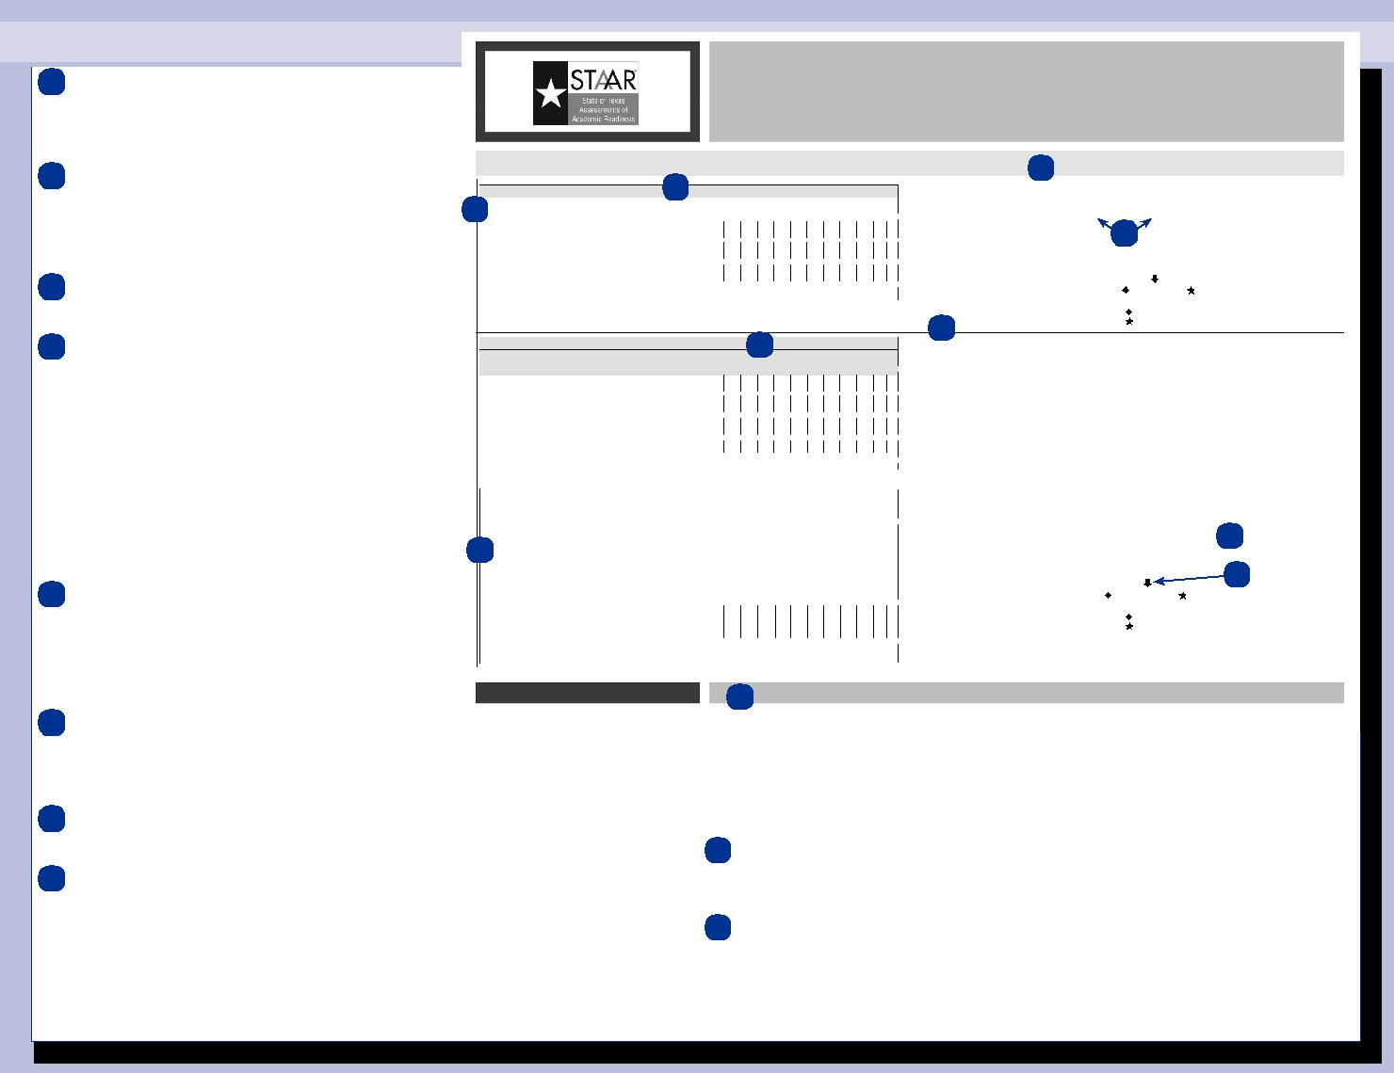

information about whether your child has made progress toward passing STAAR. The ELL